H.T No
Regulations:
A17

Sreenidhi Institute of Science and Technology
(An Autonomous Institution)
Code No: 6F302 Date: 18-Oct-2021(FN)

B.Tech II-Year I- Semester External Examination, Sept/Oct - 2021 (Supplementary)
Mathematical Foundations of Computer Science (CSE & IT)

Time: 3 Hours Max.Marks:75

Note: a) No additional answer sheets will be provided.
b) All sub-parts of a question must be answered at one place only, otherwise it will not be valued.
c) Missing data can be assumed suitably.

ANSWER ANY 5 OUT OF 8 QUESTIONS. EACH QUESTION CARRIES 15 MARKS.

Bloom's Cognitive Levels of Learning (BCLL)

Remember | L1 | Apply | L3 | Evaluate | L5
Understand | L2 | Analyze | L4 | Create | L6

 |  |  | BCLL | CO(s) | Marks
1. | a) | Show that | L2 | CO1 | [8M]
 | b) | Obtain the principal disjunctive normal form for 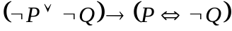 | L3 | CO1 | [7M]
2. | a) | Solve the recurrence relation 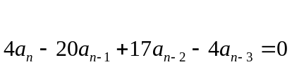 | L3 | CO2 | [8M]
 | b) | Show that 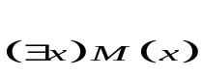 follows logically from the premises  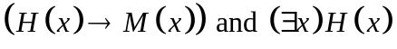 | L2 | CO2 | [7M]
3. | a) | If R and S are equivalence relations on a set A, then prove that  is an equivalence relation. | L4 | CO3 | [8M]
 | b) | Let A be a finite nonempty poset with partial order . Then prove that A has at least one minimal element and one maximal element. | L4 | CO3 | [7M]
4. |  | Prove that the set Q of rational numbers other than 1 forms an abelian group with respect to the operation * defined as 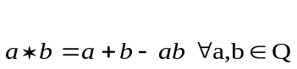 | L4 | CO4 | [15M]
5. | a) | Define binary tree. | L1 | CO5 | [8M]
 | b) | Are the following pair of graphs isomorphic. Justify your answer.  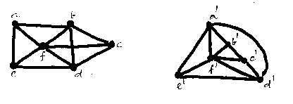 | L4 | CO5 | [7M]
6. | a) | State and prove Euler’s formula. | L4 | CO6 | [8M]
 | b) | Out of 5 males and 6 females, a committee of 5 it to be formed. Find the number of ways in which it can be formed so that among the persons chosen in the committee there are at least 2 males and one female. | L2 | CO6 | [7M]
7. | a) | Find the bounds, free and bound variables, and scope of the quantifiers in  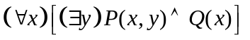 | L2 | CO1 | [8M]
 | b) | Let 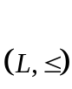 be a lattice. Then prove that 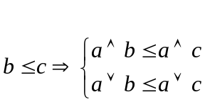 | L4 | CO2 | [7M]
8. | a) | Find a spanning tree for the following graph G, using Breadth-First Search  algorithm, in the order of vertices ‘abcdefgh’.  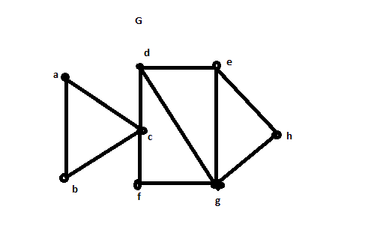 | L4 | CO4 | [8M]
 | b) | Show that in every graph, the number of vertices of odd degree is even. | L2 | CO5 | [7M]

-- 00 -- 00 –

